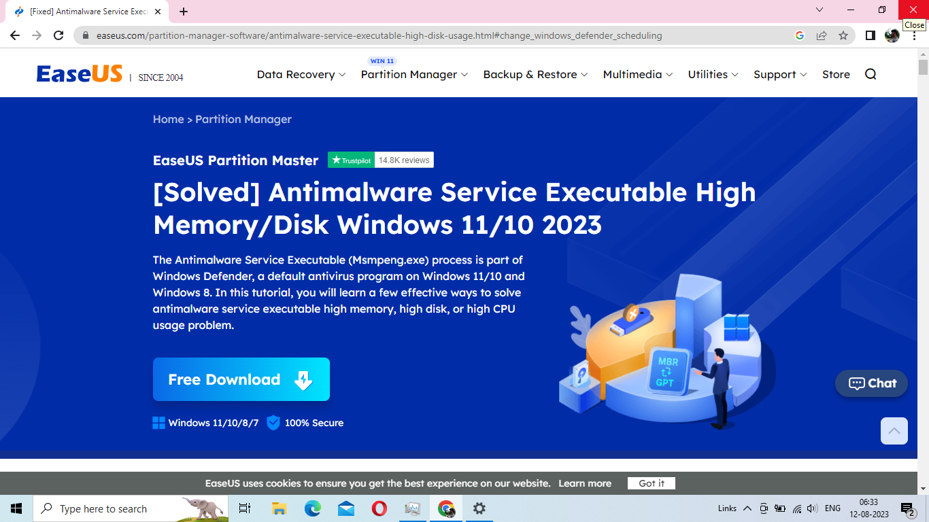

 |  |  | Project | Database | Table | Username | PWD | HOW IT WORKS
 |  | 1 | BILLING PROJECTS | billingproject1 | billingprojectpasswords sat 123 | sat | 123
 |  | 2 | teacher student interactive web | notesjr |  | for teacher satnamsingh 123456 | for student satnamsingh123456789  for teacher satnamsingh 123456
 |  | 3 | resume and percentage calculator | career_coachingjrgph |  | user_login maisha@gmail.com 12345 | user_login maisha@gmail.com 12345
 |  | 4 | certificate generation | certificatejrgph
 |  | 5 | item tracking system shop_inventoryjrgph user sss sss123 | shop_inventoryjrgph | user | sss | sss123 | how item tracking system works  1 first it contains login.php,which has footer.php  2 in footer.php ,it has <script src="assets/js/scripts.js"></script>  <script src="assets/js/login.js"></script>  3 in asserts/js/login.js it has function register() which contain url: 'model/login/register.php',  4 in register.php,database code is written  5 for login login.php ,<script src="assets/js/login.js"></script>and url: 'model/login/checkLogin.php',
 |  | 6 | old English learning skills software jrgphenglish_learning_skills_software student_register khush@gail.com 12345  for teachers satnaam@gmail.com 12345 | jrgphenglish_learning_skills_software | student_register | student_register  khush@gail.com 12345 | for teachers satnaam@gmail.com 12345 | how it works  under student_login.php it has student_check.php
 |  | 7 | covid19 jrgphcovidtmsdb admin 12345 | jrgphcovidtmsdb |  | admin 12345
 |  | 8 | new alumni chat alumni_chatjrgph user satnamsighbasran@gmail.com 1234567890 admin  student satnamsinghbasran@gmail.com 1234567890 student  student1@gmail.com 123456 student  teacher teacher1@gmail.com 123456 for teacher | alumni_chatjrgph |  | user satnamsighbasran@gmail.com 1234567890 admin | student satnamsinghbasran@gmail.com 1234567890 student  student1@gmail.com 123456 student  teacher teacher1@gmail.com 123456 for teacher
 |  | 9 | jobsiteold jrgphjob username 8 password 8 | jrgphjob |  | username 8 password 8 | username 8 password 8
 | 10 |  | jobportalmanisha jrgphjobsmanisha admin admin@gmail.com 12345  jobsseeker seeker1@gmail.com 12345 seeker2@gmail.com 12345  jobprovider first@gmail.com 12345 | manisha jrgphjob |  | admin admin@gmail.com 12345  jobsseeker seeker1@gmail.com 12345 seeker2@gmail.com 12345  jobprovider first@gmail.com 12345 | admin admin@gmail.com 12345  jobsseeker seeker1@gmail.com 12345 seeker2@gmail.com 12345  jobprovider first@gmail.com 12345
 | 11 |  | app_base_english learning skills software dbname app_base_english learning skills software  userid= satnaam@gmail.com  password= 12345 | dbname app_base_english learning skills software |  | userid= for teacher satnaam@gmail.com  password= 12345  for student  khush@gmail.com  12345
 | 12 |  | HOW PTJRGPH COLLEGE SITE WORKS |  |  |  |  | 1 IN JEESAAHIB FOLDER,IT HAS  PTJRGPH.COM,  2 IN PTJRGPH.COM IT CONTAINS ” INDEX.PHP” WHICH HAS  <?php include "./header.html" ?>  </div>  <div class="container">  <?php include "./content.html" ?>  <?php include "./social.html" ?>  <?php include "./footer.html" ?>  3) HEADER.HTML-CONTAINS HEADER INFORMATION  4)CONTENT.HTML CONTAIONS  ---FOOTER FIRST WHERE ALL SOFTWARES ARE INCLUDED  THEN  IFRAME SLIDER1.HTML  IFRAME OWL-CRAUSEL.HTML  IFRAME OUR MEMORIES.HTML
 |  |  |  |  |  |  |  | S#basran1469 jeesaahibtusaahib@gmail.com

